**Creating downloadable products**

### Downloadable Simple Products

To get started:

1. Go to: **WooCommerce > Products > Add Product** to add a new **Simple** product .
2. Tick the **Downloadable** checkbox.

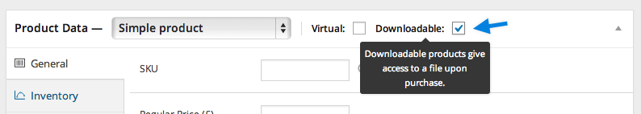

After ticking this box, other options appear: Downloadable Files, Download Limit, Download Expiry

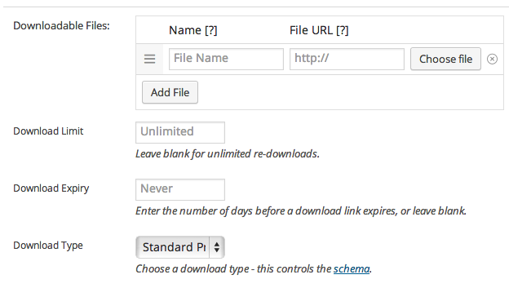

1. **Upload** a file and click Insert to set up each downloadable file URL. Match the URL of the product to the URL of your site. (i.e., if you have a www in your site URL, then make sure that is in the file URL.)
2. 4.**Enter** the Download Limit (optional). Once a user hits this limit, they can no longer download the file.
3. 5.**Enter** the Download Expiry. If you define a number of days, download links expire after that.
4. **Update**

Front end:

* 1. Follow the process of buying a particular product.(Add to cart->checkout).
  2. Once payment is done
  3. User can download the file from Account page(tab is made for account page)-> Downloads menue.
  4. Click on pdf , it will download the file.

